**DAILY ONLINE ACTIVITIES SUMMARY**

|  |  |  |  |  |  |  |  |  |
| --- | --- | --- | --- | --- | --- | --- | --- | --- |
| **Date:** | **27/05/2020** | | | | | **Name:** | **Pratibha shetti** | |
| **Sem & Sec** | **IV sem & B section** | | | | | **USN:** | **4AL18CS062** | |
| **Online Test Summary** | | | | | | | | |
| **Subjects** | | 1. **MES** 2. **KANNAD** | | | | | | |
| **Max. Marks**  **MES** | | **20** | | **Score** | | | **17** | |
| **Max marks**  **KANNAD** | | **50** | | **score** | | | **24** | |
| **Certification Course Summary** | | | | | | | | |
| **Course** | **Cloud founadtion** | | | | | | | |
| **Certificate Provider** | | | **Greatlearning academy** | | **Duration** | | | **5.0 hours** |
| **Coding Challenges** | | | | | | | | |
| **Problem Statement1:** Write a C Program to sort an array of integers in ascending order and display the sorted array and Number of passes performed for sorting  **Problem Statement2:** Given an array arr[ ] of the positive integers of size N, the task is to find the largest element on the left side of each index which is smaller than the element present at that index. Note: If no such element is found then print -1. | | | | | | | | |
| **Status: Executed** | | | | | | | | |
| **Uploaded the report in Github** | | | | | **YES** | | | |
| **If yes Repository name** | | | | | <https://github.com/pratibhashetty-123/Lockdown-coding-java>  <https://github.com/pratibhashetty-123/Lockdown-coding-for-C> | | | |
| **Uploaded the report in slack** | | | | | **YES** | | | |

**Online Test Summary:** 18CS46 test was scheduled from 12:0 pm t0 12:40pm .The portion for the IA was 2 module there were 20 questions and the time assigned was 40 minutes the questions were mcq type.

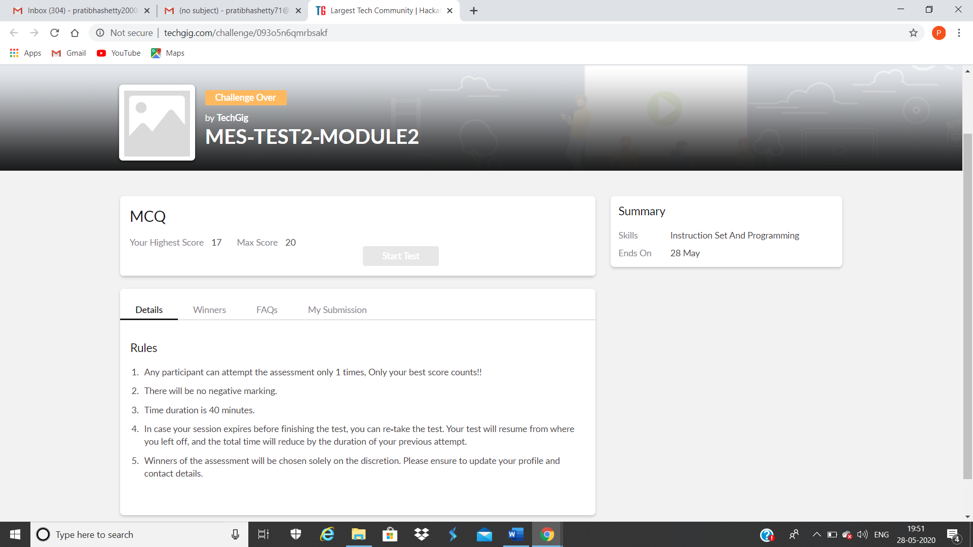

This is the snap shot of completion of the test and marks obtained.

**Online Test Summary:** kanna test was scheduled from 2:0 pm t0 2:50pm .The portion for the IA was 10 modules there were 50 questions and the time assigned was 50 minutes the questions were mcq type.

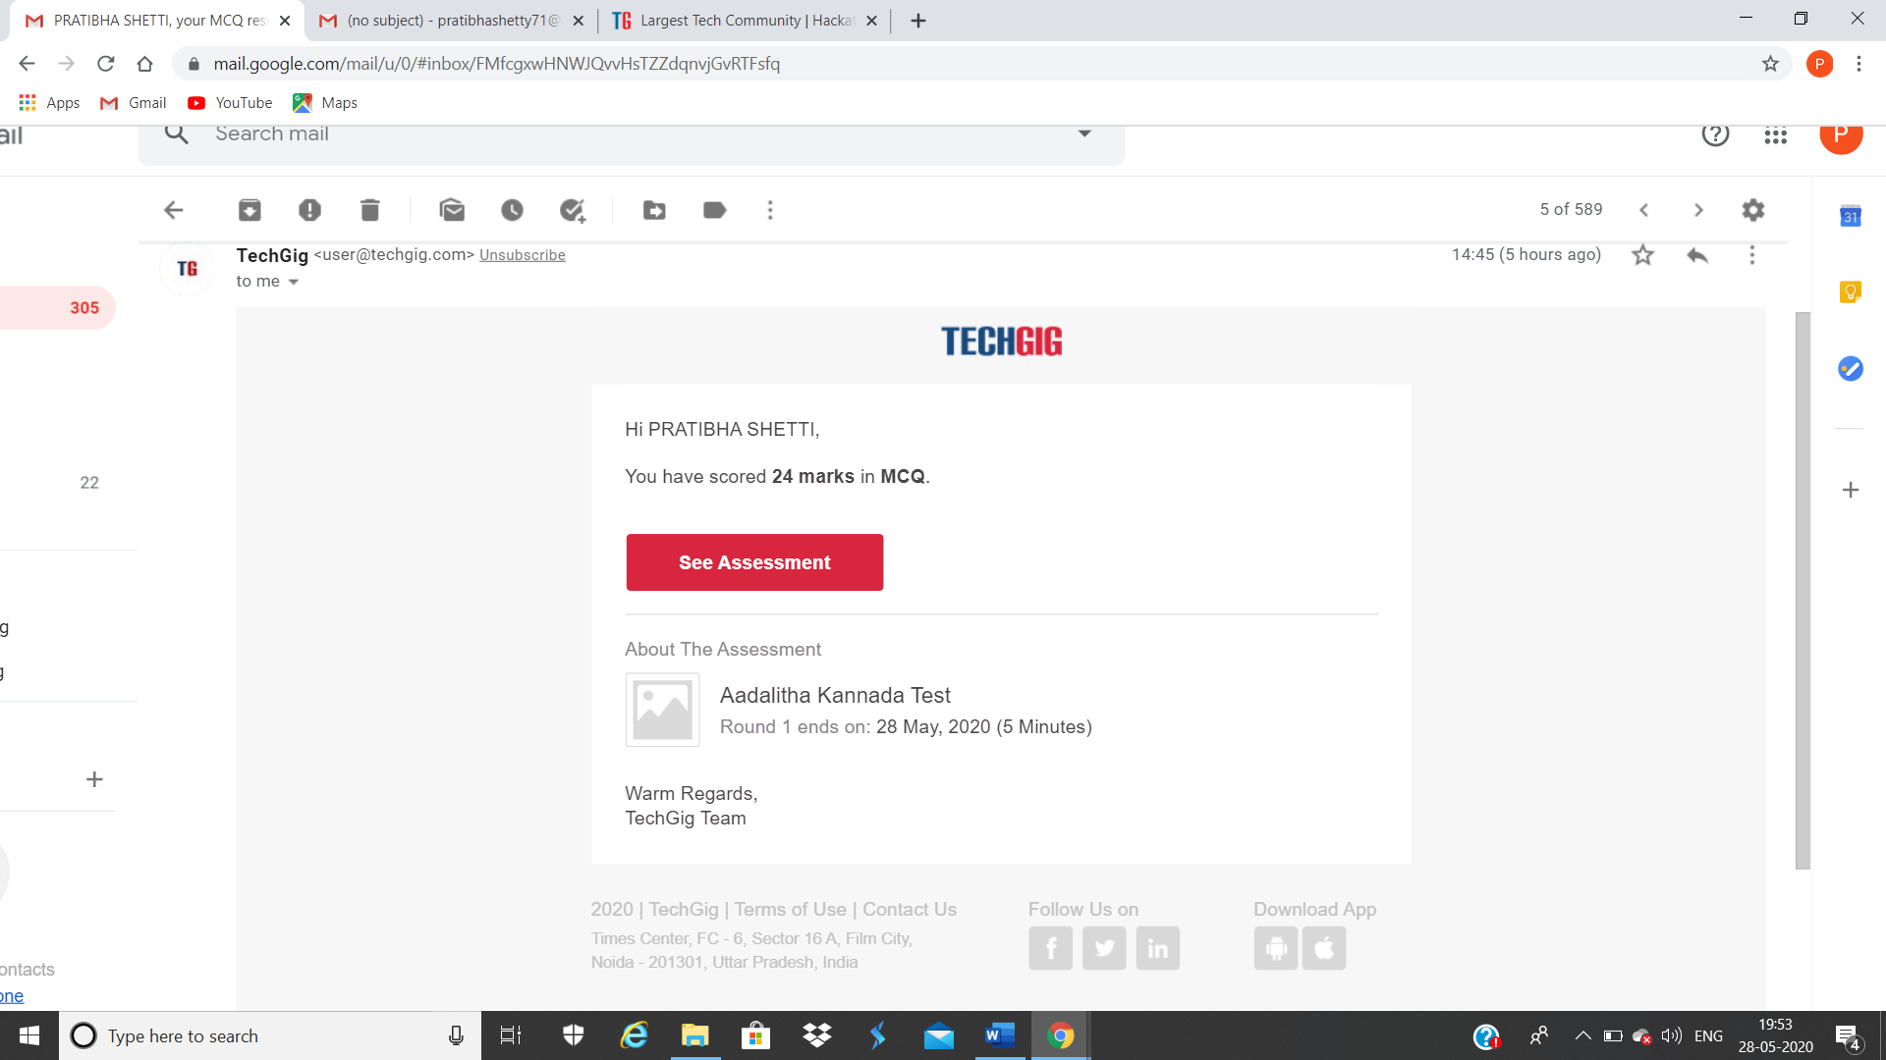

This is the snap shot of completion of the test and marks obtained

Online Certification Summary: In today’s session I have learnt about price, economics, data velocity, and distributing computing and challenges for distributed computing.



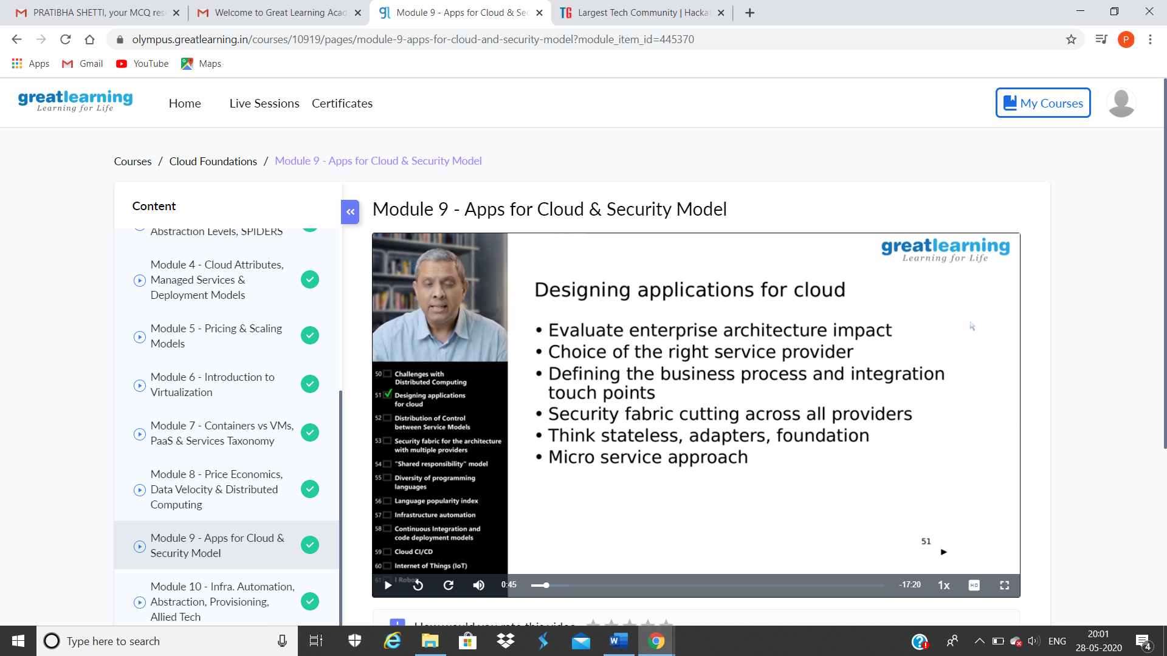

These are the snap shots of today’s sessions.

Online Coding Summary: **Today I had received one program from prof.**

**Merlyn Mathias CSE Dept. The program is mentioned above in the**

**coding challenges(pg.01). I have also uploaded it to my Github**

**repository.**

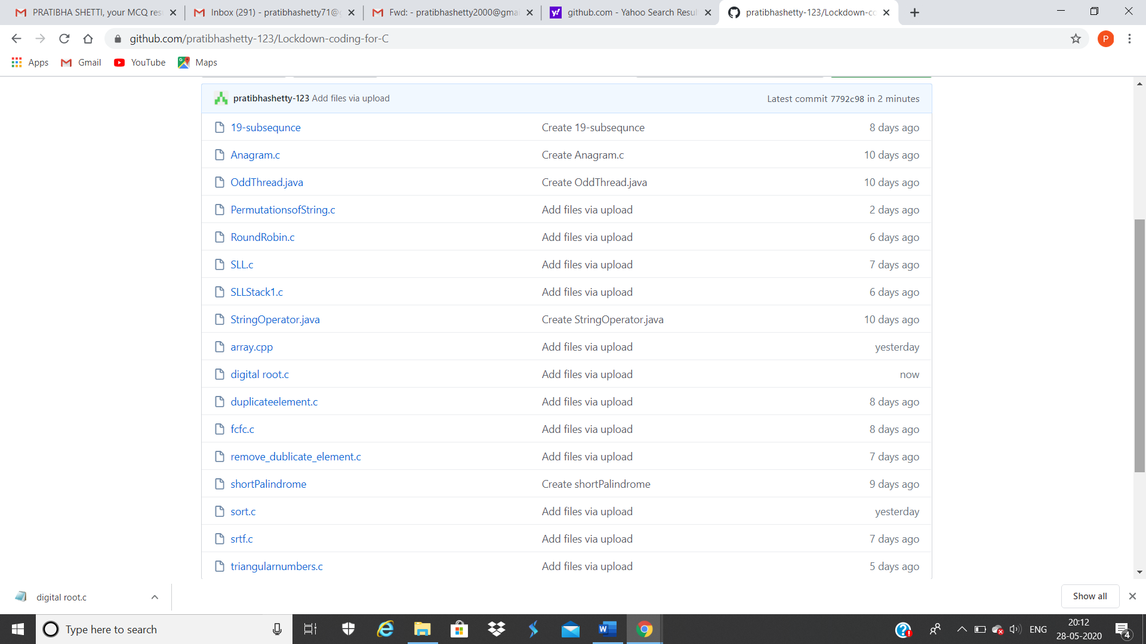

**This is the snap shot of my Github repository** were I have uploaded the code. File name digital root.c

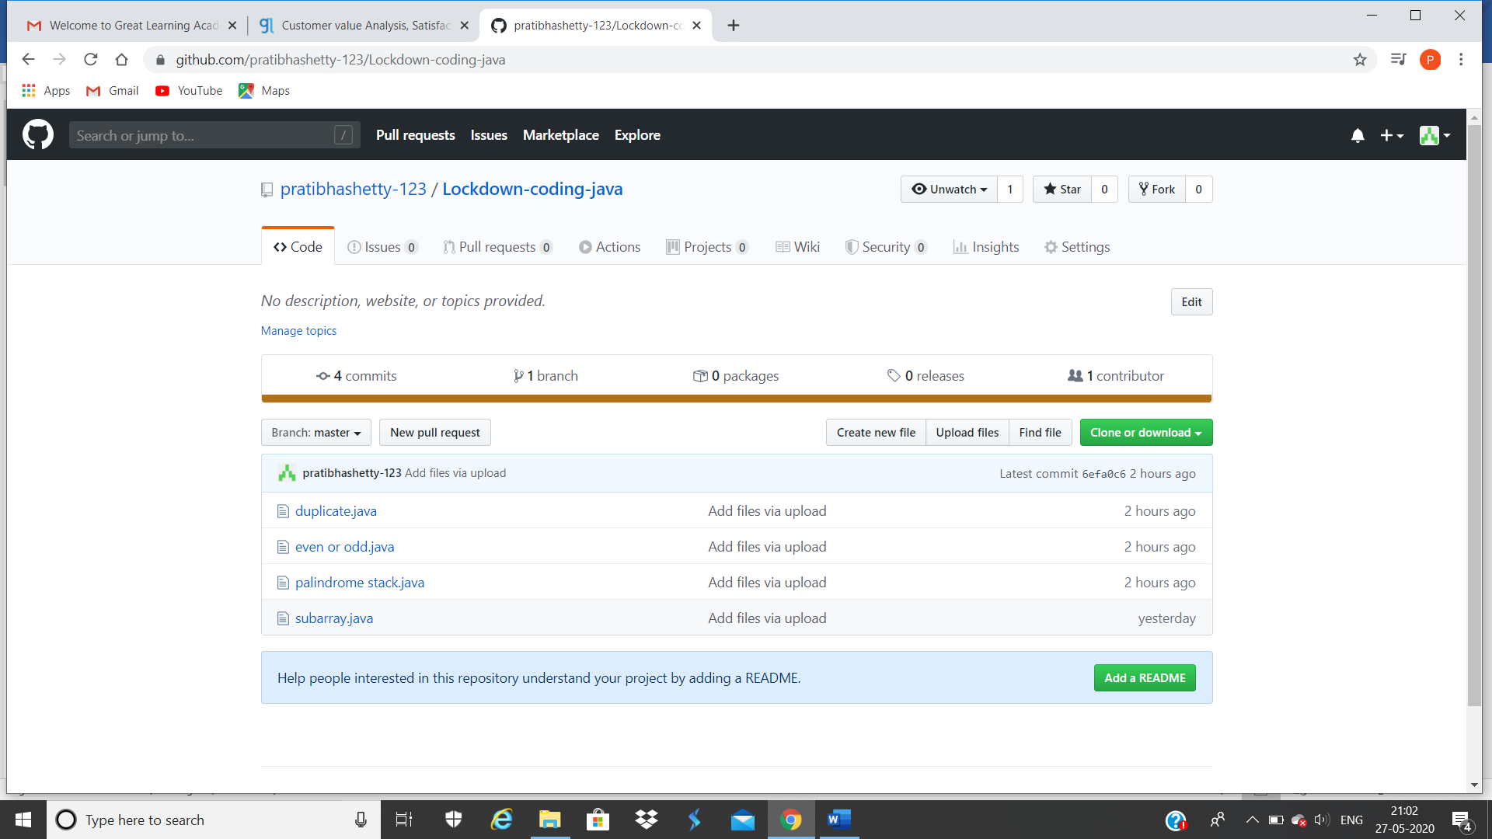

**These are Java codes snap shot**